IBM CLOUD SERVICES

|  |  |
| --- | --- |
| DATE | 16 November 2022 |
| TEAM ID | PNT2022TMID48639 |
| PROJECT TITLE | IoT based smart crop protection system for agriculture. |

A cloud object storage service:

STEP 1:

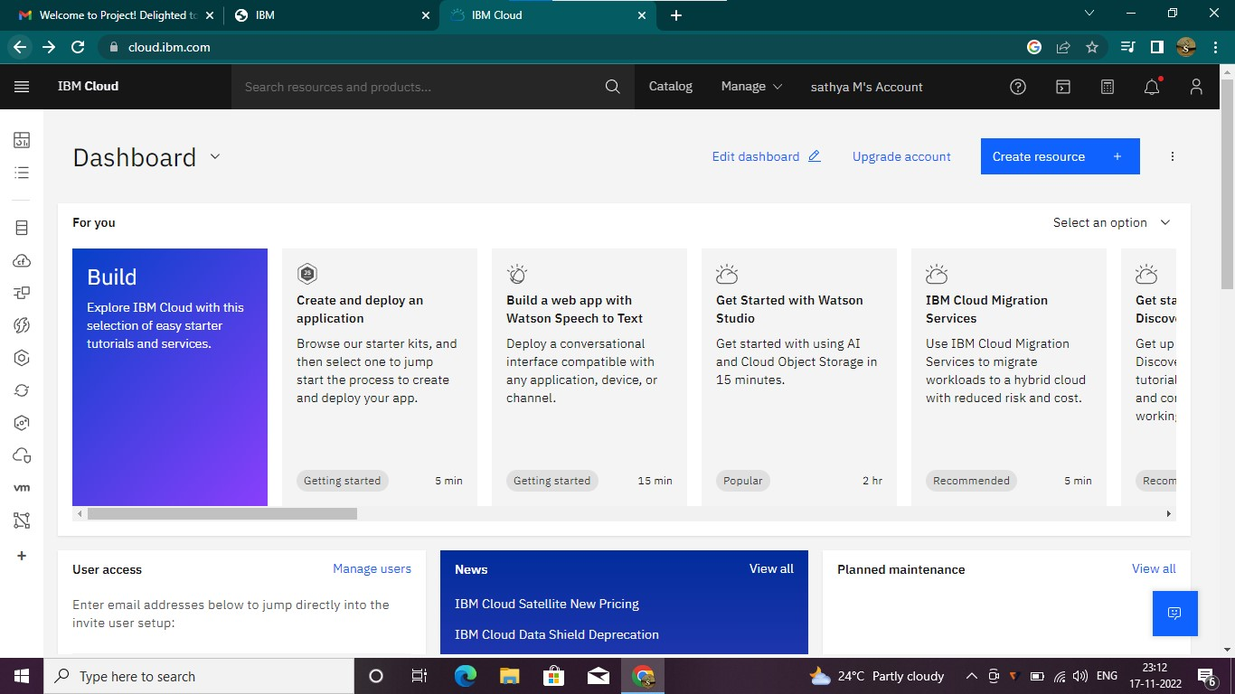

STEP 2:

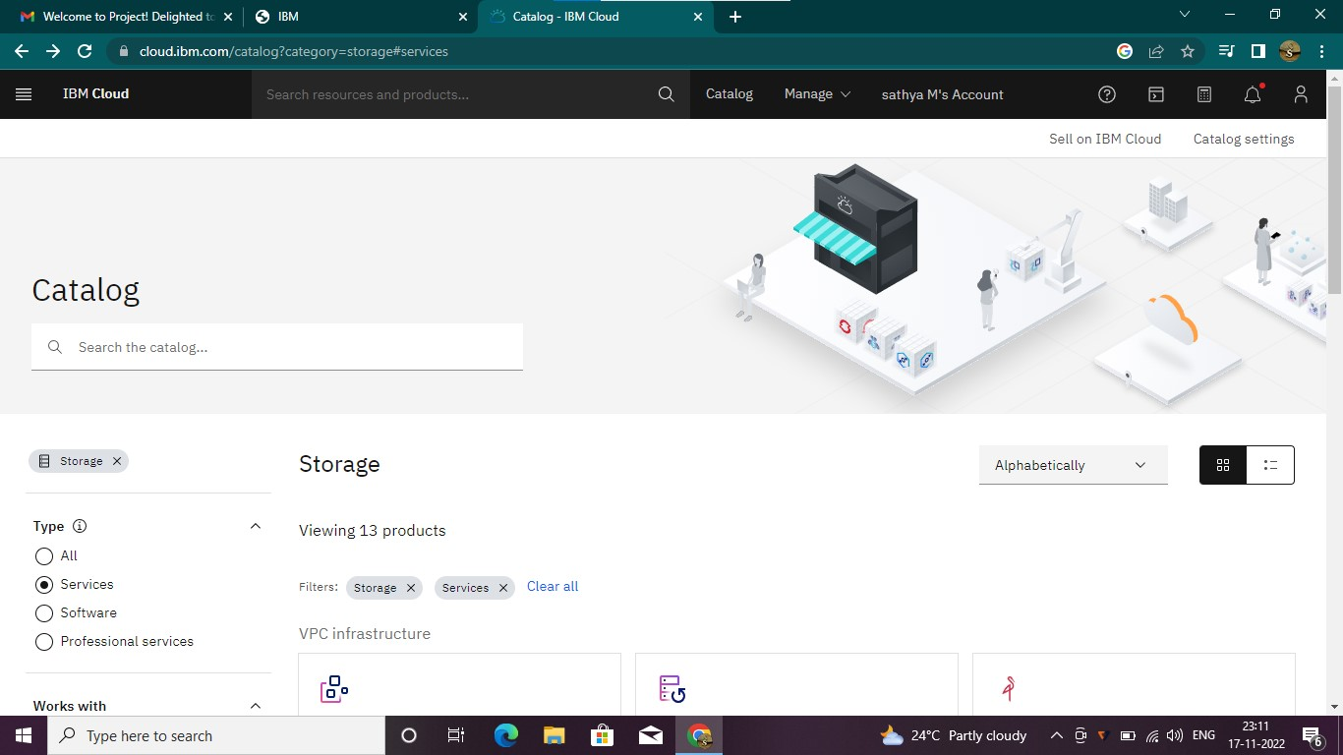

STEP 3:

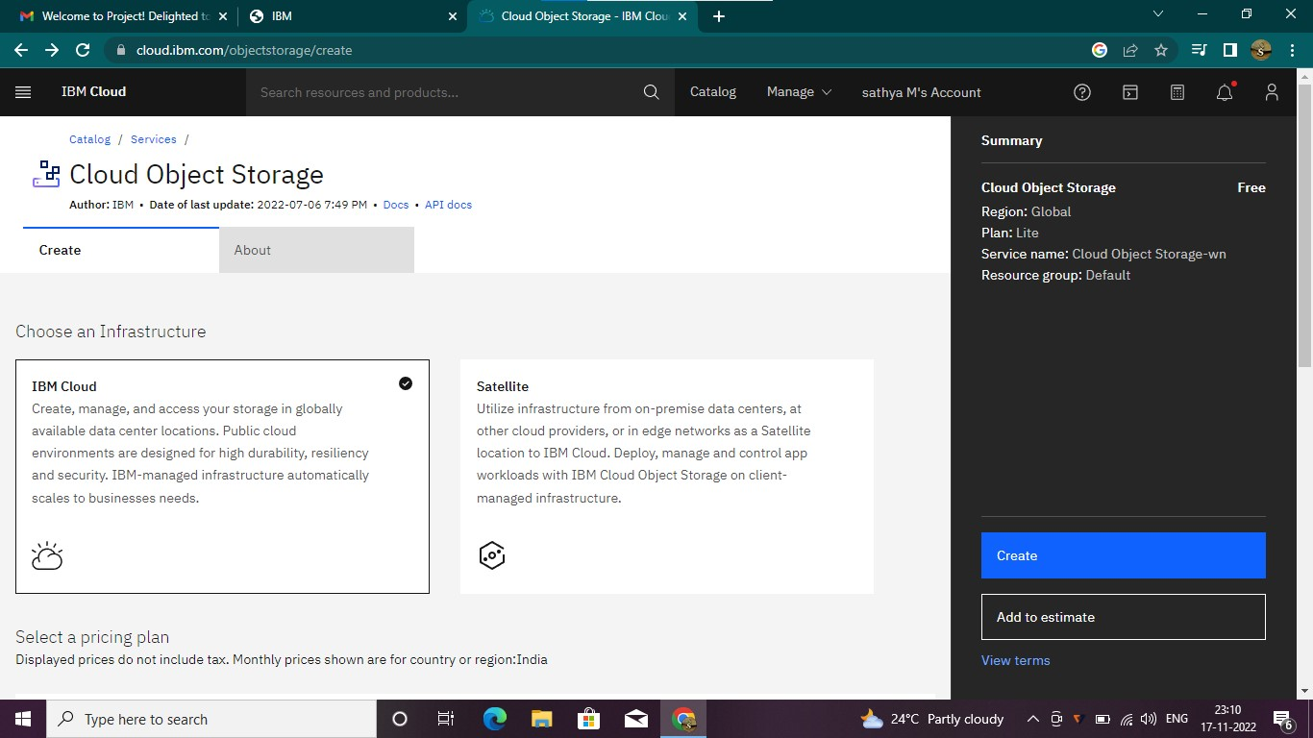

STEP 4:

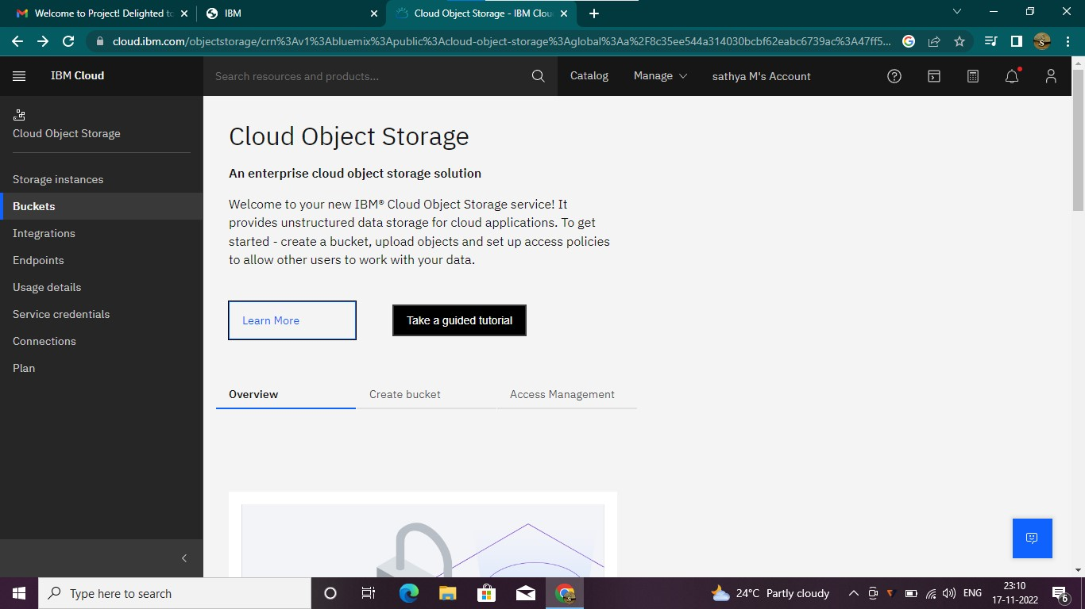

STEP 5:

